1. Add “Client Approval Required?” to Blend section.

Entity: BlendSection

Property: IsClientApprovalRequired

1. Add “Execution Oder” to Job Type section

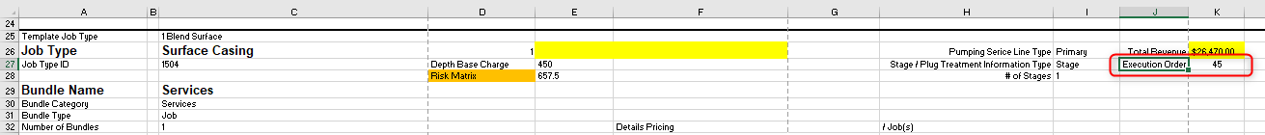

Entity: ProgramPumpingJobSection

Property: ExecutionOrder

1. Add Rig Name to Well Location

Entity: WellLocationInformation

Property: Rig

1. Add Well Type

Import sheet location: as above image

Entity: BottomHoleConditionSection

Property: WellType

1. Add Well Objective

Import sheet location: as above image

Entity: Program

Property: WellObjective